CHAPTER 2

INSTALLATION

Contents:
- System Requirements
- Installation Instructions
- Starting SDS HelpDesk
- License Agreement and Code
- Updating your SDS HelpDesk License Code
- User Logon

System Requirements
- Windows 95, Windows 98, or Windows NT 4.0.
- IBM-compatible PC with 486DX2/66 or higher microprocessor.
- 16 megabytes of RAM. 32 megabytes of RAM is recommended.
- Hard drive with 25 megabytes of free disk space.
NOTE: This is the amount of free disk space needed to install the program and system files. The amount of disk space needed to run SDS HelpDesk depends on the amount of data you enter into the program.
- SVGA (800 x 600) resolution video display.
- CD-ROM Drive.
- Mouse.
- Printer.

Installation Instructions

Default Installation - All Program Files Are Installed on a Single Computer
- Close all applications currently running.
- Insert the CD-ROM into your CD-ROM drive.
- Click the Start button, then click Run.
- Type your CD-ROM drive letter followed by “:\” (e.g., D:\).
- Click OK.
- Follow the instructions on the setup screen.
Installation Instructions (cont’d)

Network Installation – All Program Files Are Installed on a Single Computer, but the Database File is Moved to a Network Server
- Close all applications currently running.
- Insert the CD-ROM into the your CD-ROM drive.
- Click the Start button, then click Run.
- Type the CD-ROM drive letter followed by “:\” (e.g., D:\).
- Click OK.
- Follow the instructions on the setup screen.
- Create an SDS HelpDesk folder in the route directory of the server. Select the HelpDesk folder, and then create a subfolder of it called Database.
- Move the database file (called HelpDesk.mdb) from your local computer into the Database folder on the server. This step only needs to be done once by the system administrator.
- Each licensed user needs to set the path to the database file on the server. This is done through the Connect to Database process.

Starting SDS HelpDesk
SDS HelpDesk starts the same way as other Windows programs.
- Click the Start button.
- Select the Programs option.
- Select HelpDesk.
The first time you start SDS HelpDesk you are greeted by a welcome screen that is shown only once.

License Agreement and Code
Users of SDS HelpDesk must have a valid SDS Software License and license code. There are two types of license codes. One is a temporary code, which expires after a reasonable evaluation period. Your temporary demo code is entered for you automatically when you install SDS HelpDesk. The other is a permanent code. This code is given to users who register and purchase the software. Once you register the program, email Scott Data Systems for a permanent license code.
- Start SDS HelpDesk. The following dialog box opens.
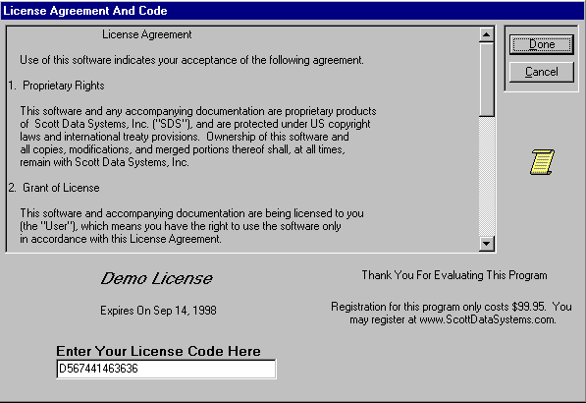
- Your current License Code is displayed. Demo licenses also display the expiration date. An unregistered version of the program will not function after the evaluation period until it becomes registered.
- If you have not already done so, be sure to read the License Agreement. Click the Done button.

License Agreement and Code (cont’d)
- You need to logon and enter a password whenever you start SDS HelpDesk. The first time you start the program, a screen will ask for the “ADMIN” password. Enter “admin” which is the initial password for the system administrator. This password can be changed at a later time when you have entered more users.
After you have been added as a user and have been given an initial password, enter your password whenever you start the program.

You are now ready to begin using SDS HelpDesk.

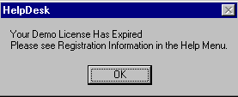
The following dialog box opens when the evaluation period expires on a demo license code. Close the dialog box. Click the Help menu and select the Registration Information option. This will provide instructions on how to register the program and obtain a permanent license code.
License Has Expired Dialog Box

Updating your SDS HelpDesk License Code
You need to update your SDS License Code when you register the program, or if you need additional evaluation time on a demo license. Click the Help menu and select the Registration Information option. This will provide instructions on how to register the program and obtain a permanent license code.
- Click the File menu. Select the License option to open the following dialog box.
Enter your new License Code here.

- Enter the new license code in the edit box.
- Click the Done button.

User Logon
Whenever you start SDS HelpDesk you will be asked to enter your password. The system administrator must set up users and their initial passwords from the Admin, Users menu option. See Chapter 5 for details.
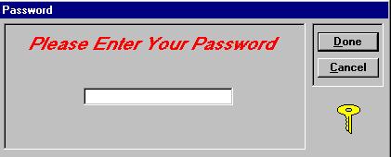
Password Dialog Box

- Select your user name from the User drop down list in the toolbar.
- Enter your password in the edit box. Click the Done button.
- You will be notified if you enter an invalid password. Passwords are case sensitive, so be sure to enter yours correctly.
You can change your password at any time by using the Modules menu, Change Password option. See Chapter 5 for details.

